Requirement:

**The external signal Unblank is a TTL 5V signal. Modular contains no overvoltage protection. The active level is high**.

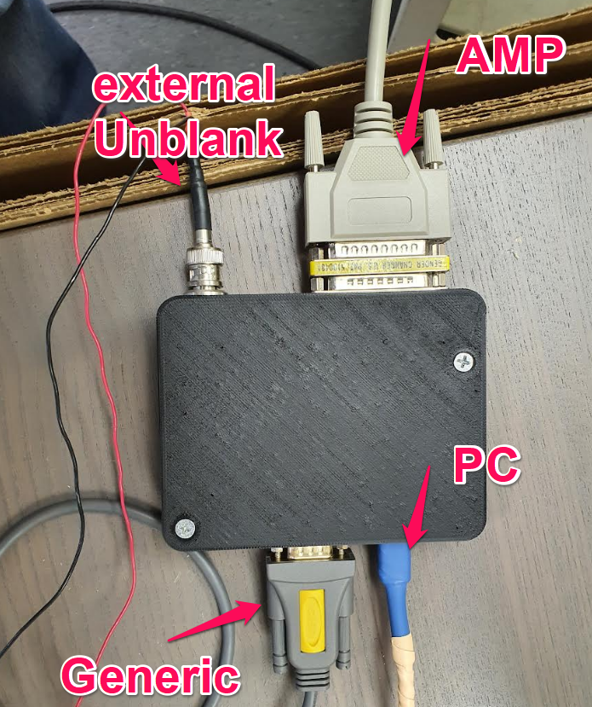

***Generic is an access to the information com port of the amplifier. You can see additional information on the operation of the amplifier by connecting this jack to your PC.***

1. Connect the module to the computer via USB. **It is important that the amplifier is turned off**.

2. Make sure the module is detected by the system. You should see a new COM device.

3. Run the main.exe file. You may need to deactivate the firewall or antivirus program in the background in order to identify and install the program .

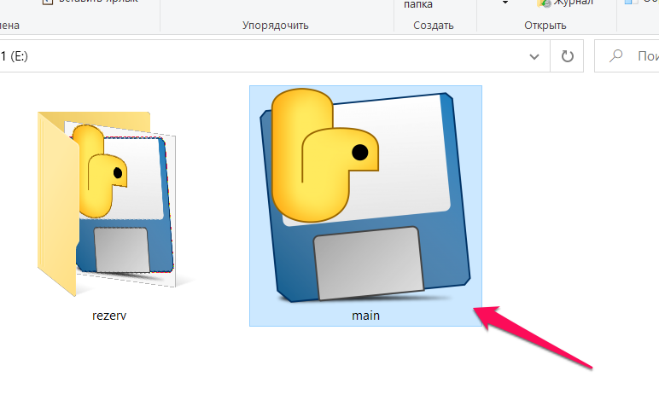

4. Select the desired com port address. And press the Connect button.

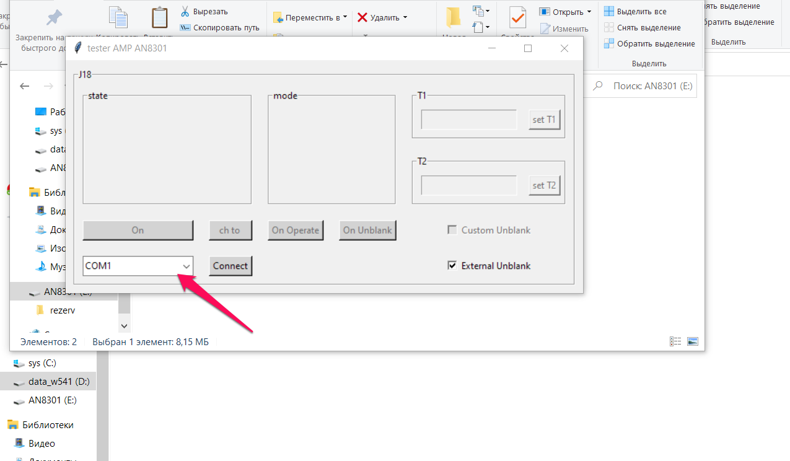

5. After the connection has been successfully made, you should be able to see the state indicating “connect to MCU”.

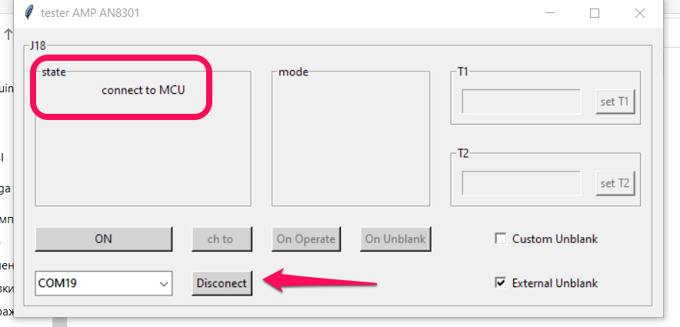

6. By default it is assumed that you will be using an external Unblank signal source.

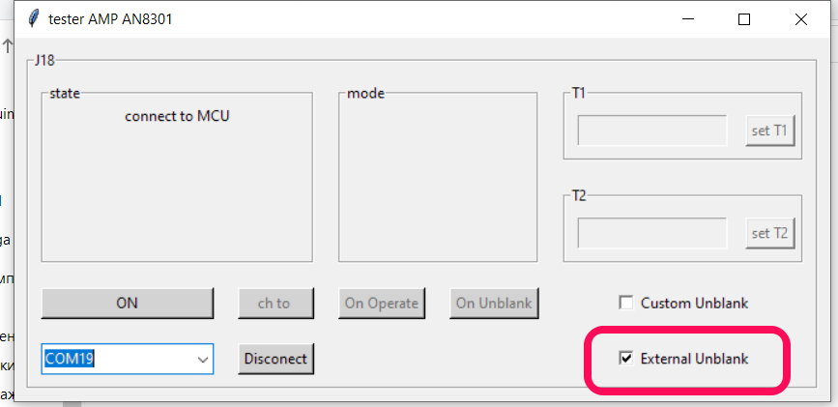

7. You can use the internal Unblank generator. The maximum pulse period is 1000ms and the maximum pulse length is 60ms (this limitation is imposed by the amplifier). By default, the period is 400ms and the pulse width is 3.5ms. These are the parameters used in MRI. This function does not check for erroneous data entry.

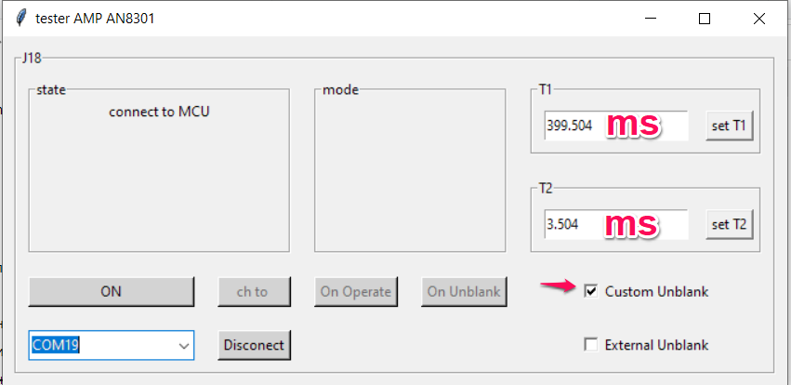

8. Now turn on the switch breaker from the Amplifier. Wait for 40 seconds and proceed the next step

9. Click the On button. The amplifier initialization process begins.

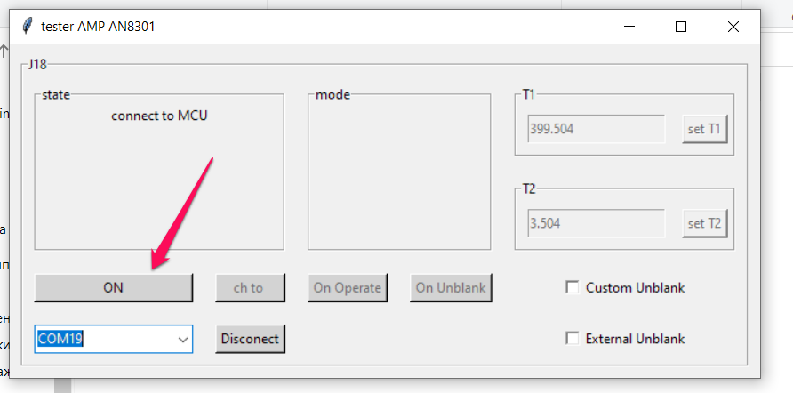

10. It is necessary to wait until the Standby mode is established.

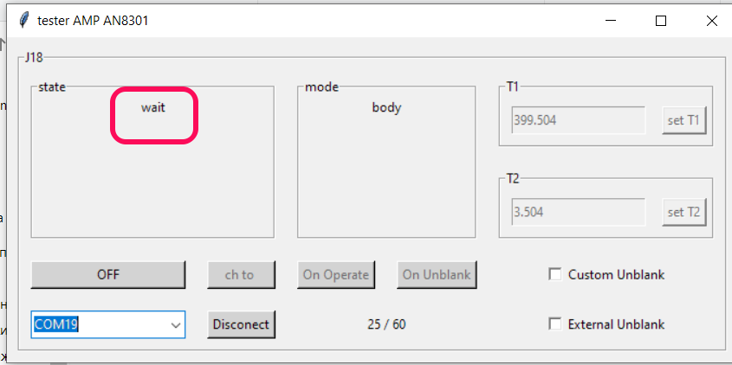

11. Once the standby is enabled, the button will become active for you to choose between Head or Body signal channel. Once you complete the selection, you can click ‘on operate’ to initiate the RF signal output.

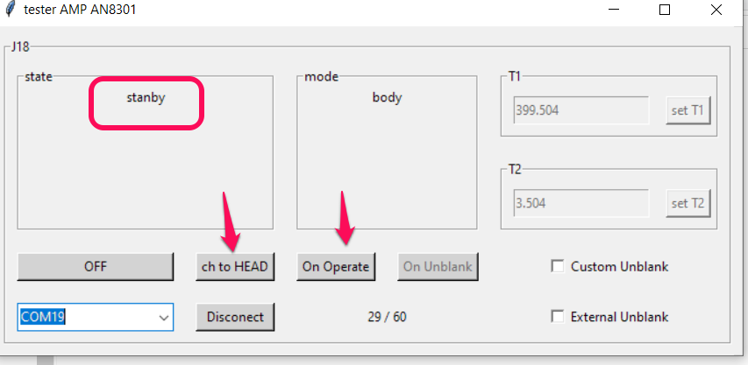

11. If the ‘external Unblank’ is selected, the amplifier requires external unblank signal to be connected and received in order to operate.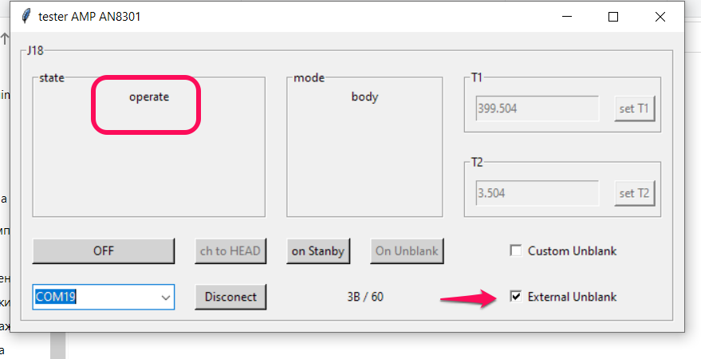

12. If ‘External Unblank’ is not selected, you can click On Unblank button to feed an unblank signal in order for the amp to operate.

